**Step 1-** go to manage Jenkins and there configure E-mail notification option

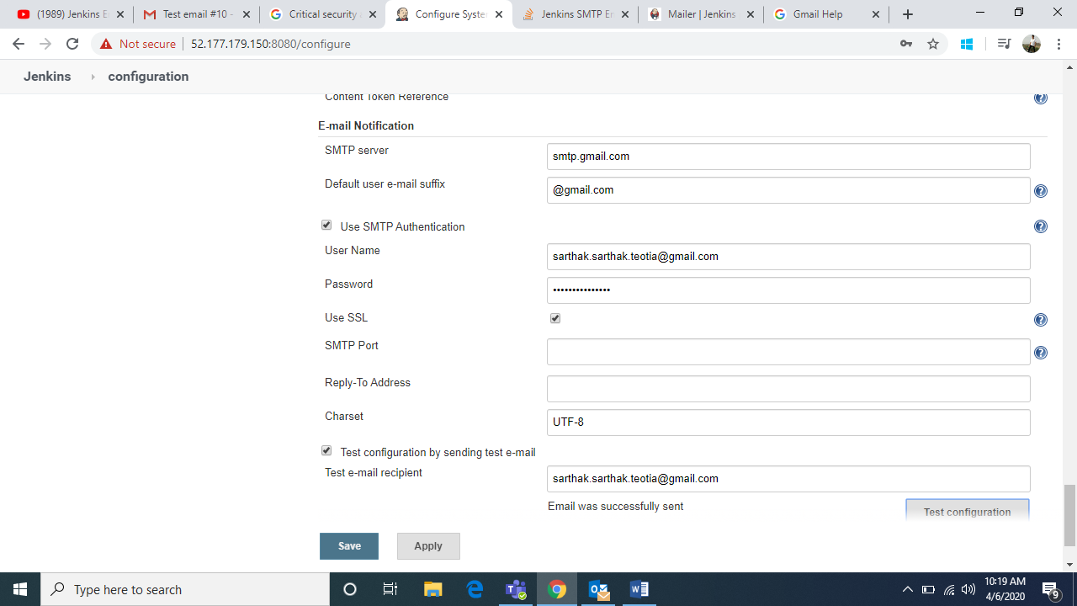

**Step 2-** send a test email and see it in your mail

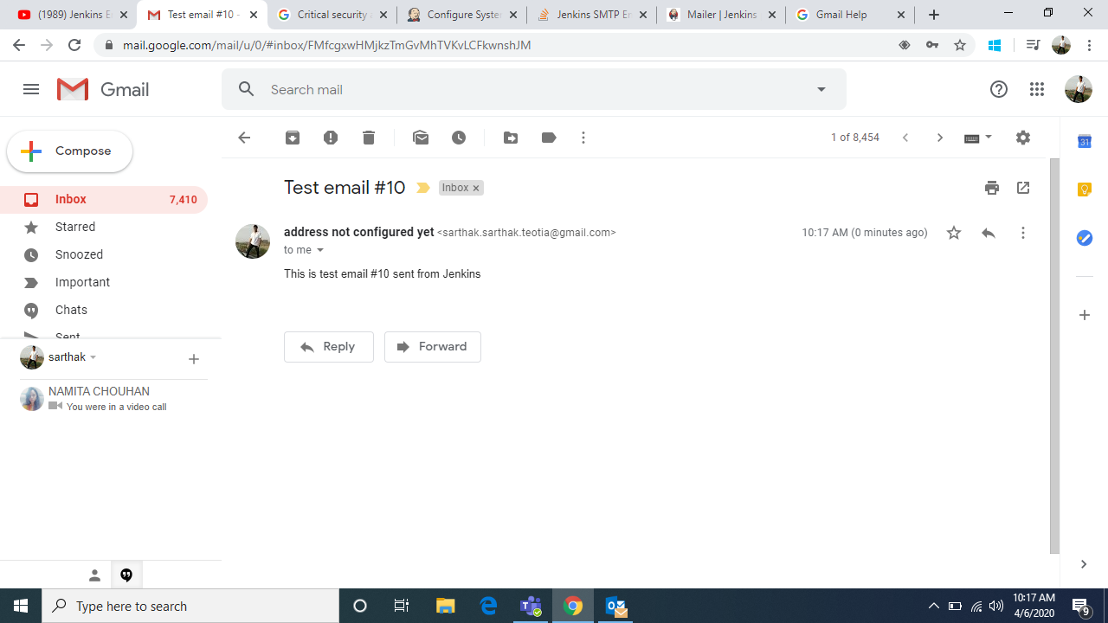

**Step 3-** enter the recipients email address to which the notification is supposed to be sent

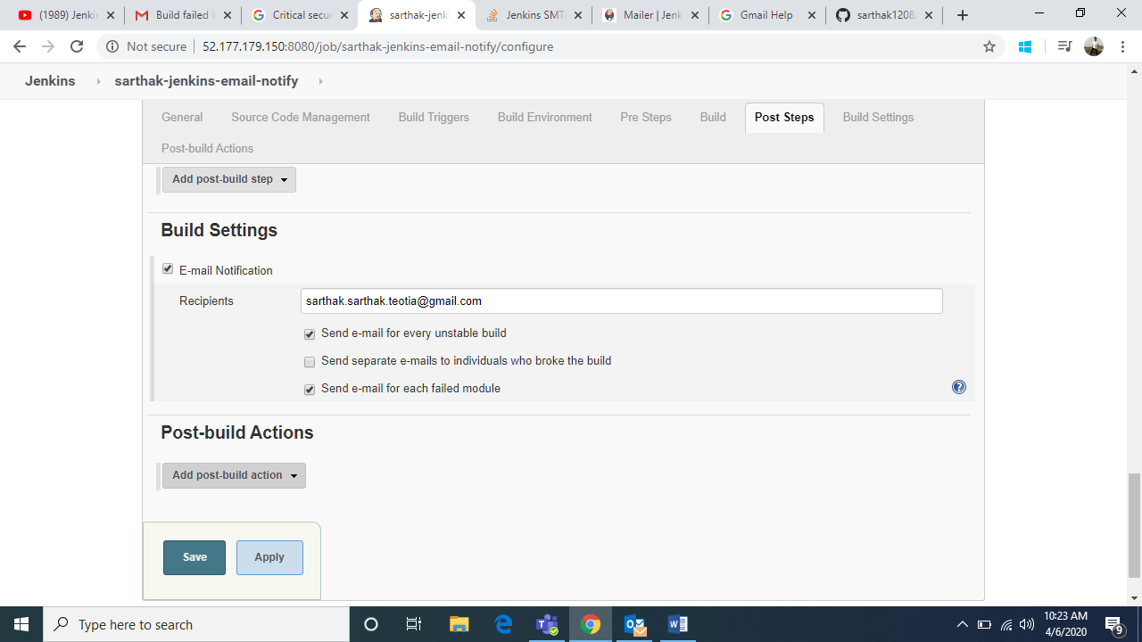

**Step 4-** create build

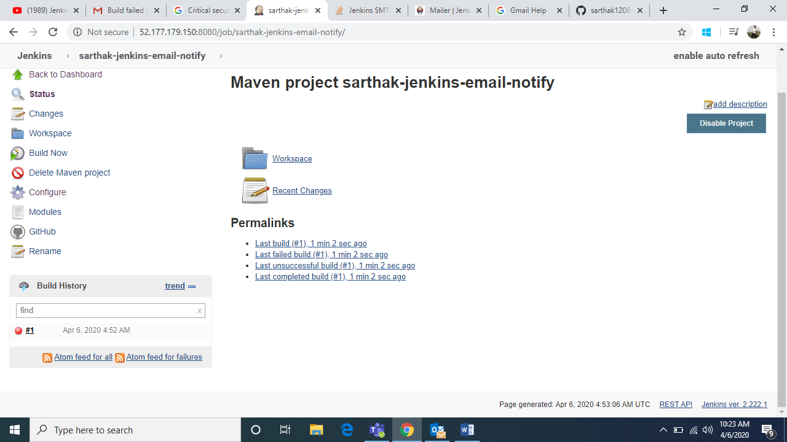

**“finally you will receive a notification on your email with complete logs of the build”**

